**CONFIGURING ATTRIBUTE ASSISTANT TABLES**

This document will show you how to setup the Attribute Assistant Tool used in Esri ArcMap. This document assumes you have already downloaded the the tool onto your local drive. This download is available from the Esri site or from the Garland GIS team.

The Atrribute Assistant Tool allows users to create rules that automatically fill-in attribute fields according to rules the user sets up. The DynamicValue table holds the different rules, their parameters, and their settings. The GenerateID table is used specifically with the GenerateID rule in the DynamicValue table. It tracks the “current state” of the field populated with the GenerateID rule so you can adjust the number interval, starting number, and other settings for each field that uses the GenerateID rule.

In order for the Attribute Assistant Tool to work, you need to meet 3 conditions:

1. Ensure that the 2 tables are in the same geodatabase as the layers/tables for which you are going to be creating rules
   1. In other words, you will want to have a copy in the Test environment and eventually the Produciton environment, after confirming in Test that everything is working properly
2. Ensure that the DynamicValue and GenerateID tables have the Domains they need listed in their properties
3. Ensure that the names of the tables in the configuration file you downloaded match the names of the tables in the geodatabase
   1. In Garland, each department has their own DynamicValue and GenerateID tables, so you will need to rename your tables

This document covers the steps you need to take in order to meet all 3 condditions.

To meet the first condition for the Assistant Attribute Tool to work:

1. Ensure that the 2 tables are in the same geodatabase as the layers/tables for which you are going to be creating rules
   1. In other words, you will want to have a copy in the Test environment and eventually the Produciton environment, after confirming in Test that everything is working properly

There are instructions from Esri on how to complete this condition. The below link is included in the download file in the “Getting Started” file.

**Tip:** When Copying and Pasting the tables in to the desired geodatabase, do not use the Import tool, this will not carry over the necessary properties. Rightclick the table and select Copy, and then rightclick the desired geodatabase’s name and select Paste.

http://solutions.arcgis.com/shared/help/attribute-assistant/

To meet the second condition for the Assistant Attribute Tool to work:

1. Ensure that the DynamicValue and GenerateID tables have the Domains they need listed in their properties
2. In the Catalog pane, right click on the newly added DynamicValue table. Go to the Subtypes tab and click on “Domains”.

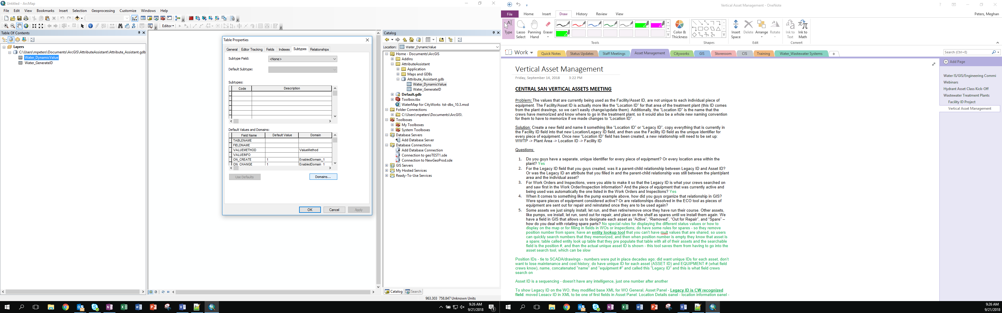

1. In the “Domains” pop-up, verify that the following Domains are listed: ValueMethod, EnableDomain, and BooleanDomain

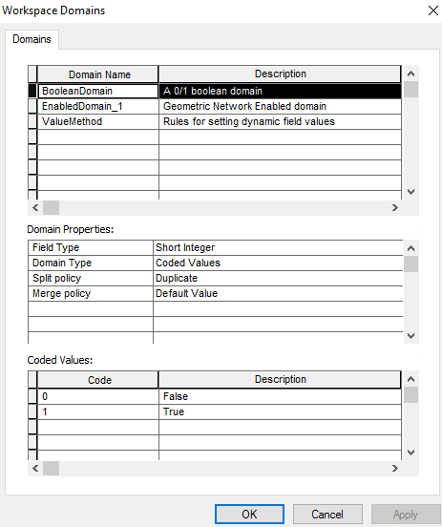

1. Follow the same steps to check the newly added GenerateID table. If one or both of the tables do not have the domains listed, you will need to delete the tables and try copying and pasting them into the desired geodatabase again.

To meet the third condition for the Assistant Attribute Tool to work:

1. Ensure that the names of the tables in the configuration file you downloaded match the names of the tables in the geodatabase
   1. In Garland, each department has their own DynamicValue and GenerateID tables, so you will need to rename your tables

**\*\*IT IS IMPERATIVE THAT THE NAME OF THE TABLE IN ARCMAP EXACTLY MATCHES THE NAME OF THE TABLE LISTED IN THE CONFIGURAITON FILE, OR THE ATTRIBUTE ASSISTANT TOOL WILL NOT WORK.\*\***

1. In the Catalog pane, doubleclick on the DynamicValue table you added to get the cursor. It is best practice to use the following format (you need to fill-in the highlighted section with your department’s name):
   1. “Department_DynamicValue”
   2. “Department_GenerateID”

The names of your tables must be unique from the other DynamicValue and GenerateID tables that exist for other departments in the geodatabase.

For example, the Water Department’s tables are named “Water_DynamicValue” and “Water_GenerateID”.

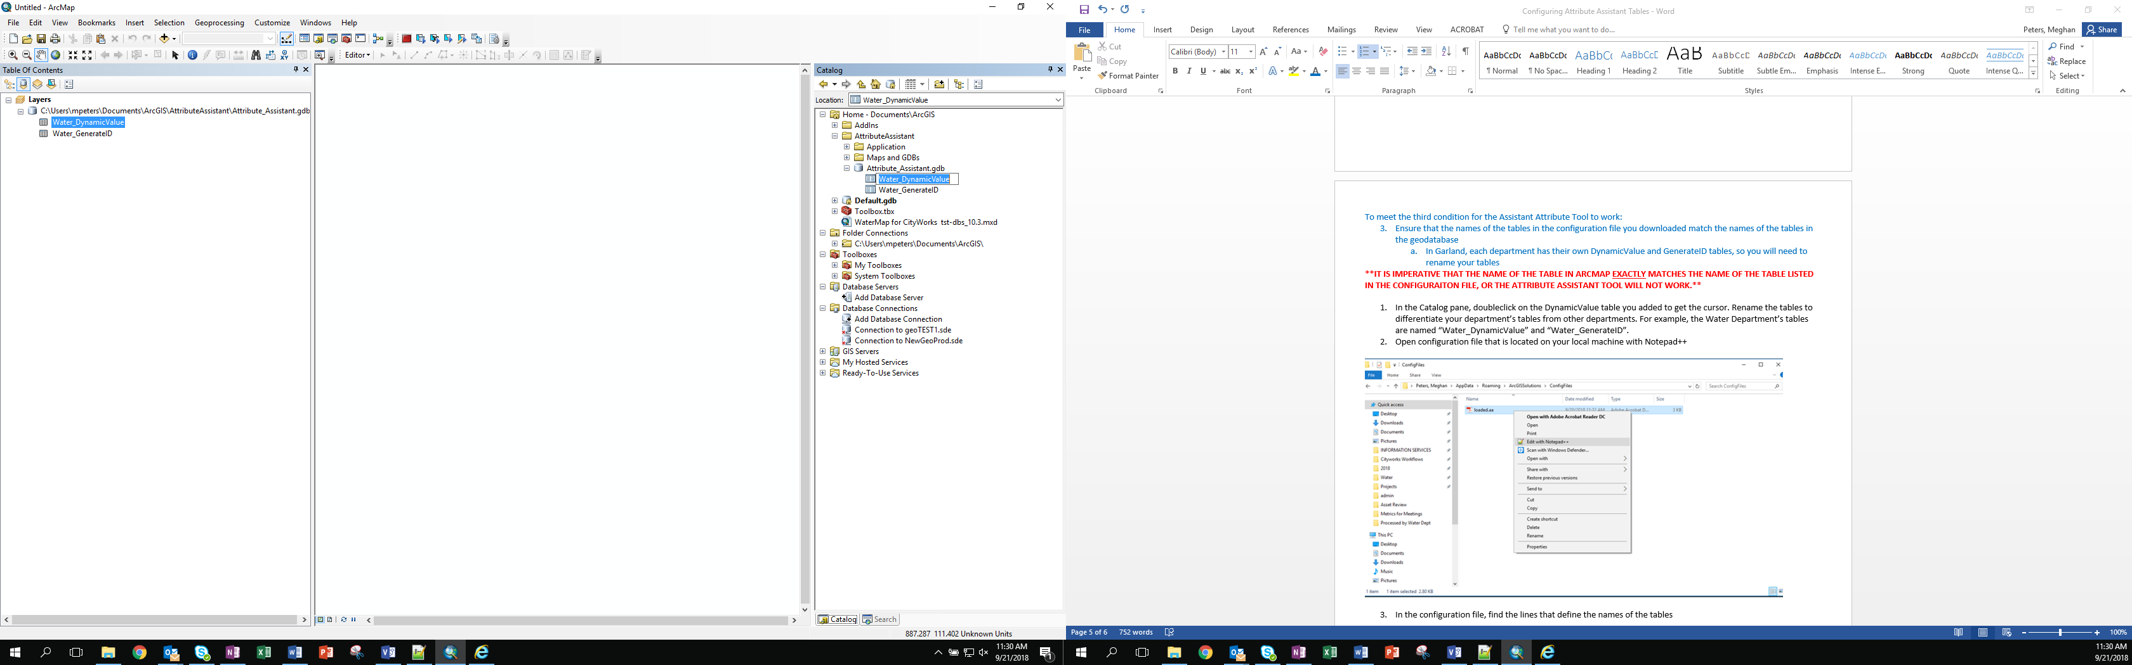

1. Open configuration file that is located on your local machine with Notepad++

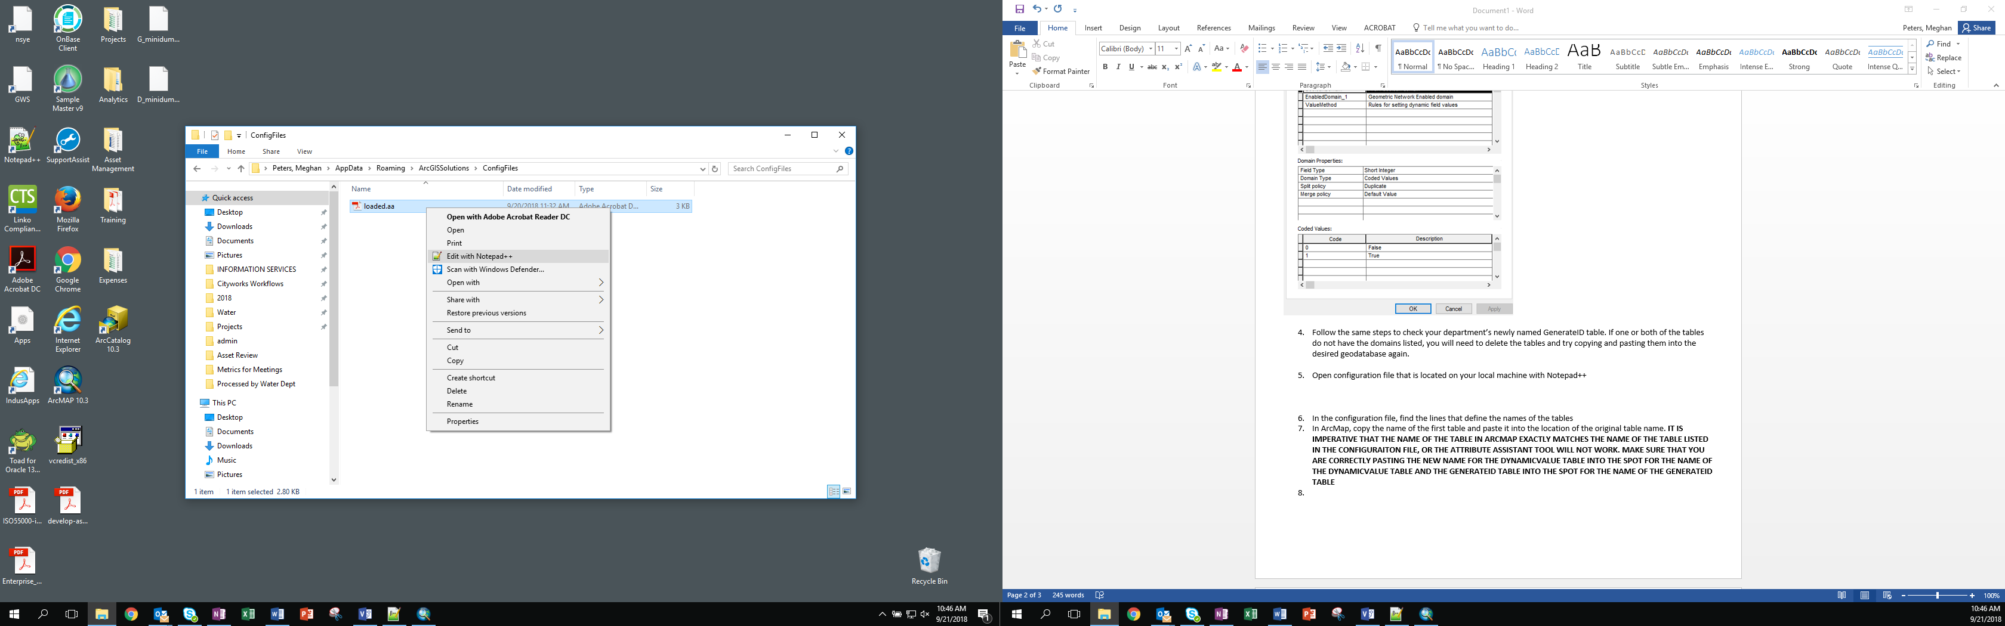

1. In the configuration file, find the lines that define the names of the tables

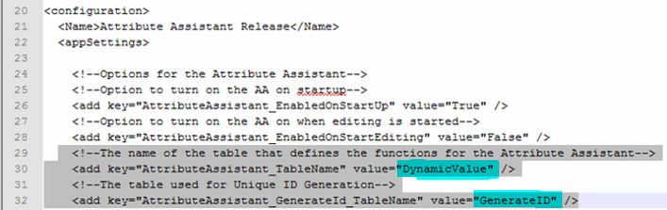

1. In ArcMap, doubleclick on the name of the DynamicValue table to get the cursor, rightclick, copy the name and paste it into the location of the original table name.

**\*\*MAKE SURE THAT YOU ARE CORRECTLY PASTING THE NEW NAME FOR THE DYNAMICVALUE TABLE INTO THE SPOT FOR THE NAME OF THE DYNAMICVALUE TABLE AND THE GENERATEID TABLE INTO THE SPOT FOR THE NAME OF THE GENERATEID TABLE\*\***

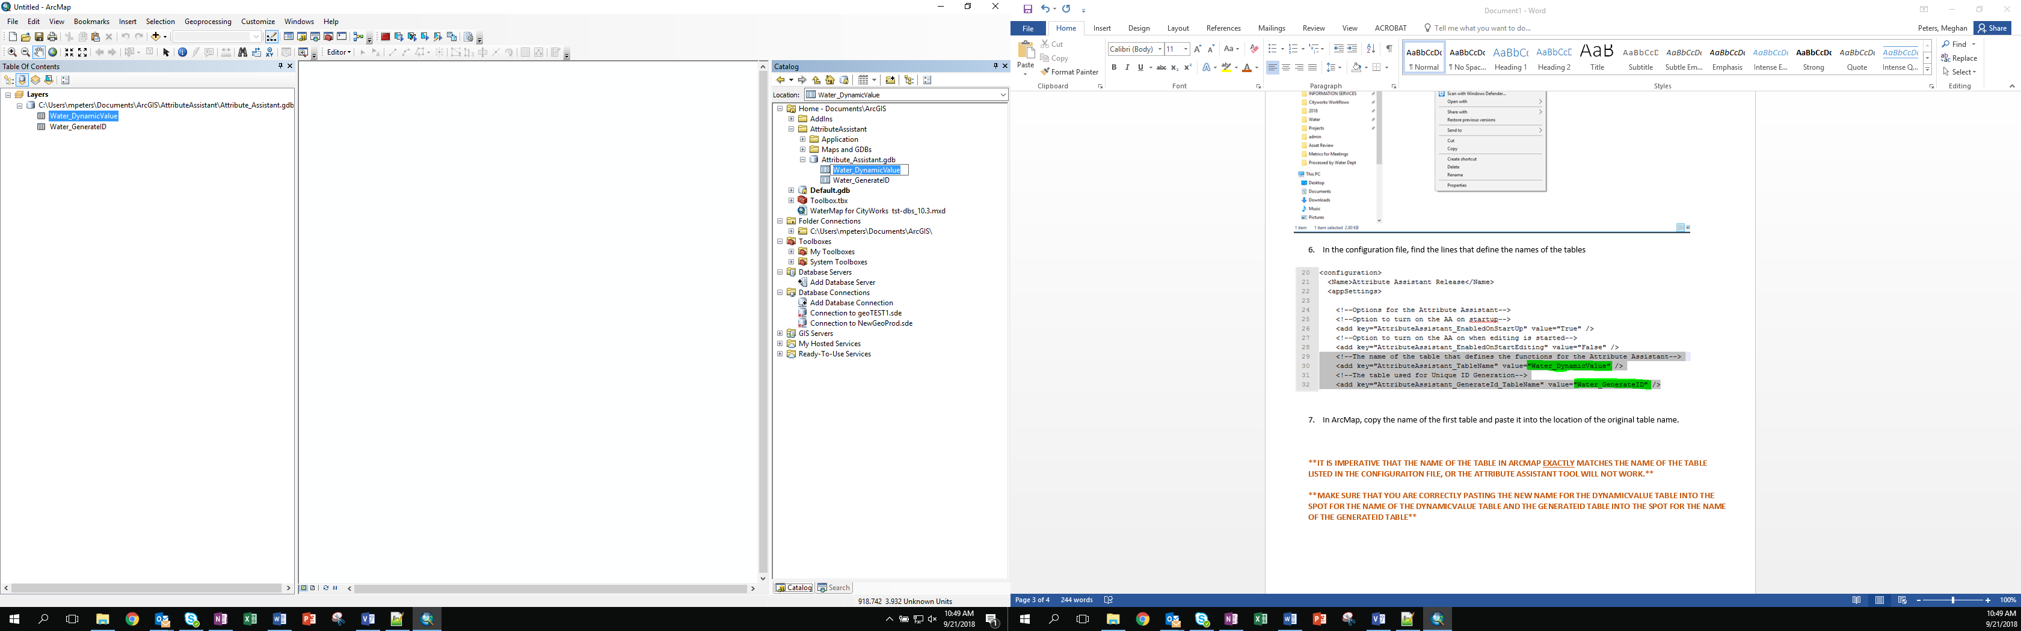



“DynamicValue” is now “Water_DynamicValue”

1. Copy and paste the new name for the GenerateID table using the same instructions as above.

“GenerateID” is now “Water_GenerateID”